Save the game using conquese map

run following command

1. loadmap starwar.map
2. gameplayer -add Mike Random -add Rik Random
3. assigncountries
4. savegame game1

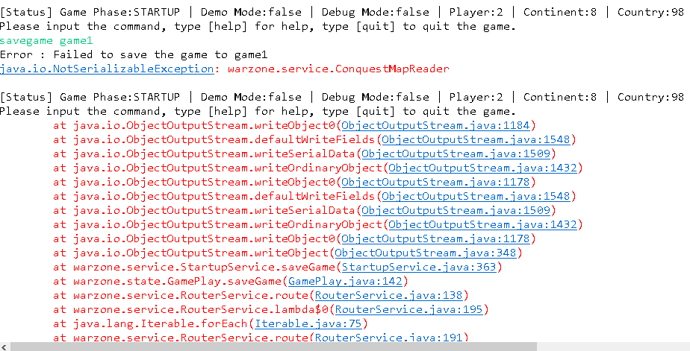

### Use regular map, savemap is working, error occured when loadmap

following commands

1. loadmap starwar.map
2. gameplayer -add Mike Random -add Rik Random
3. assigncountries
4. savegame game1
5. reboot
6. loadgame game1

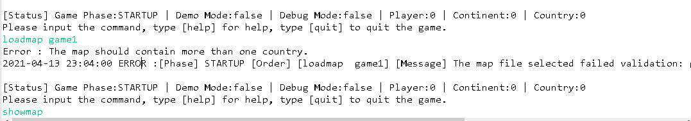

### 3 army from Canada to attack England(3 army), Canada win, it is wrong.

Was assigned to derek

***************************************************************************************

** Continent[Bonus Army] - Country - neighbors - Armies - State[Player - Status - Army In Pool] **

***************************************************************************************

1 North_Europe[5]

1 England 3 Occupied [jack - AGGRESSIVE - Alive - 0 ]

2 Scotland

3 Canada

4 US

2 Scotland 0 Occupied [tom - RANDOM - Alive - 3 ]

1 England

3 Canada

4 US

7 COUNTRY-7

2 East_Europe[4]

3 Canada 3 Occupied [rik - AGGRESSIVE - Alive - 0 ]

1 England

2 Scotland

4 US

4 US 3 Occupied [max - HUMAN - Alive - 0 ]

1 England

2 Scotland

3 Canada

5 COUNTRY-5

5 COUNTRY-5 0 Occupied [jack - AGGRESSIVE - Alive - 0 ]

1 England

4 US

6 COUNTRY-6

6 COUNTRY-6 0 Occupied [max - HUMAN - Alive - 0 ]

2 Scotland

5 COUNTRY-5

3 CONTINENT-3[6]

7 COUNTRY-7 3 Occupied [mike - BENEVOLENT - Alive - 0 ]

1 England

8 COUNTRY-8

8 COUNTRY-8 0 Occupied [mike - BENEVOLENT - Alive - 0 ]

9 COUNTRY-9

9 COUNTRY-9 0 Occupied [tom - RANDOM - Alive - 3 ]

10 COUNTRY-10

10 COUNTRY-10 0 Occupied [rik - AGGRESSIVE - Alive - 0 ]

7 COUNTRY-7

------------------------------------------------------------------------------------------------------------------------------

Canada[rik] is attacking England[jack]:

------------------------------------------------------------------------------------------------------------------------------

England defeated an army of Canada: 4 <= 6

Canada defeated an army of England: 6 <= 7

England defeated an army of Canada: 0 <= 6

Canada defeated an army of England: 2 <= 7

England defeated an army of Canada: 0 <= 6

Canada failed to defeat an army of England: 9 > 7

Success : Success to execute order:Advance Order, issued by player [rik], sending [3] armies from [Canada] to [England]

2021-04-14 00:17:49 Success :[Phase] OrderExecution [Order] ADVANCE [Message] Advance Order, issued by player [rik], sending [3] armies from [Canada] to [England]

***************************************************************************************

** Continent[Bonus Army] - Country - neighbors - Armies - State[Player - Status - Army In Pool] **

***************************************************************************************

1 North_Europe[5]

1 England 1 Occupied [rik - AGGRESSIVE - Alive - 0 ]

2 Scotland

3 Canada

4 US

2 Scotland 0 Occupied [tom - RANDOM - Alive - 3 ]

1 England

3 Canada

4 US

7 COUNTRY-7

2 East_Europe[4]

3 Canada 0 Occupied [rik - AGGRESSIVE - Alive - 0 ]

1 England

2 Scotland

4 US

4 US 3 Occupied [max - HUMAN - Alive - 0 ]

1 England

2 Scotland

3 Canada

5 COUNTRY-5

5 COUNTRY-5 0 Occupied [jack - AGGRESSIVE - Alive - 0 ]

1 England

4 US

6 COUNTRY-6

6 COUNTRY-6 0 Occupied [max - HUMAN - Alive - 0 ]

2 Scotland

5 COUNTRY-5

3 CONTINENT-3[6]

7 COUNTRY-7 3 Occupied [mike - BENEVOLENT - Alive - 0 ]

1 England

8 COUNTRY-8

8 COUNTRY-8 0 Occupied [mike - BENEVOLENT - Alive - 0 ]

9 COUNTRY-9

9 COUNTRY-9 0 Occupied [tom - RANDOM - Alive - 3 ]

10 COUNTRY-10

10 COUNTRY-10 0 Occupied [rik - AGGRESSIVE - Alive - 0 ]

7 COUNTRY-7